Word Search Answers
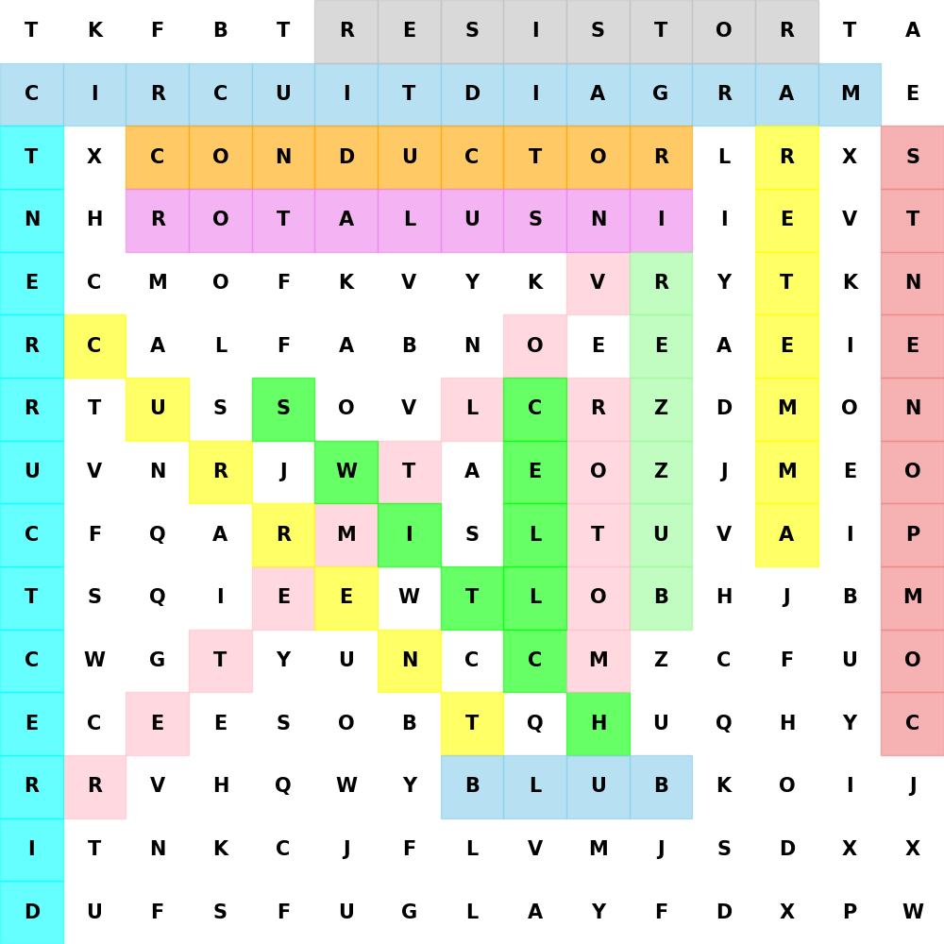

Answer Key
1. Buzzer: An audio signalling device that produces a buzzing sound when an electric current passes through it.
2. Negative terminal: The terminal of a battery or cell where current flows in.
3. Motor: A machine that converts electrical energy into mechanical energy.
4. Voltmeter: A device used to measure the voltage or potential difference between two points in a circuit.
5. Conductor: A material that allows electric current to flow through it easily.
6. Alternating Current: An electric current that periodically reverses direction.
7. Insulator: A material that does not allow electric current to flow through it.
8. Ammeter: An instrument used to measure electric current in a circuit.
9. Circuit diagram: A graphical representation of an electrical circuit using symbols for components.
10. Direct Current: An electric current that flows in one direction only.
11. Positive terminal: The terminal of a battery or cell where current flows out.
12. Resistor: A component that limits or regulates the flow of electric current in a circuit.
13. Cell: A single unit that generates electrical energy through chemical reactions.
14. Current: The flow of electric charge through a conductor, measured in amperes (A). It is the rate at which charge passes through a point in a circuit.
15. Components: The individual parts or elements that make up an electrical circuit.
16. Switch: A device used to open or close a circuit, controlling the flow of electricity.
17. Potential difference: The difference in electric potential between two points in a circuit, measured in volts (V). It represents the work done to move a unit charge from one point to another.
18. Bulb: A device that produces light when an electric current passes through it.

